Build Your DB Server and Interact with Your DB Using an App
Amazon Relational Database Service (Amazon RDS) makes it easy to set up, operate, and scale a relational database in the cloud. It provides cost-efficient and resizable capacity while managing time-consuming database administration tasks, which allows you to focus on your applications and business. Amazon RDS provides you with six familiar database engines to choose from: Amazon Aurora, Oracle, Microsoft SQL Server, PostgreSQL, MySQL and MariaDB.

By the end of the lab, you will have this infrastructure:
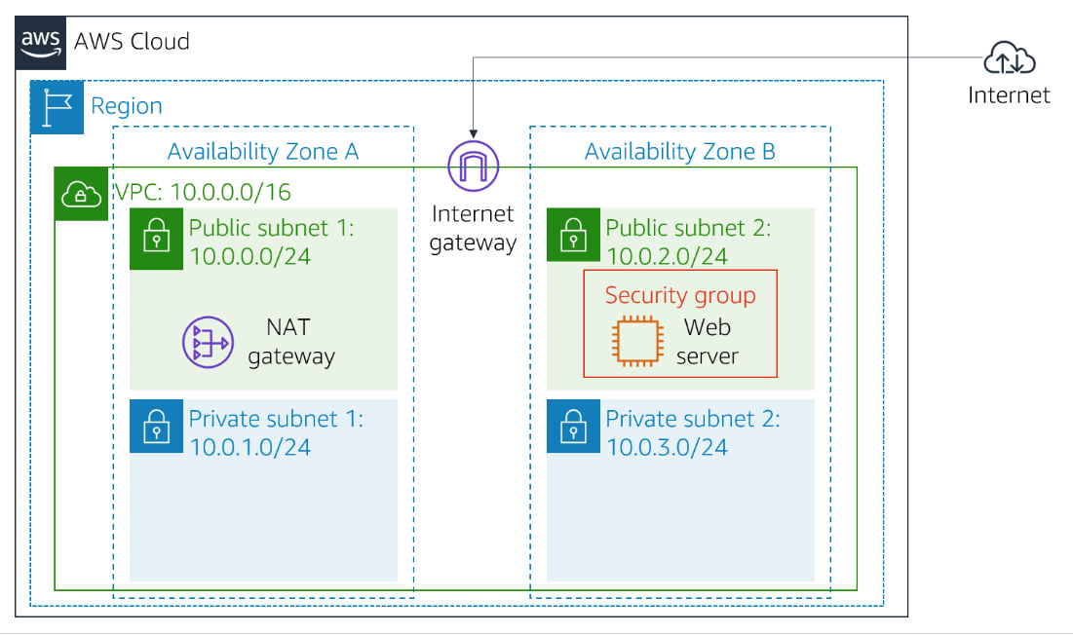
By the end of the lab, you will have this infrastructure:
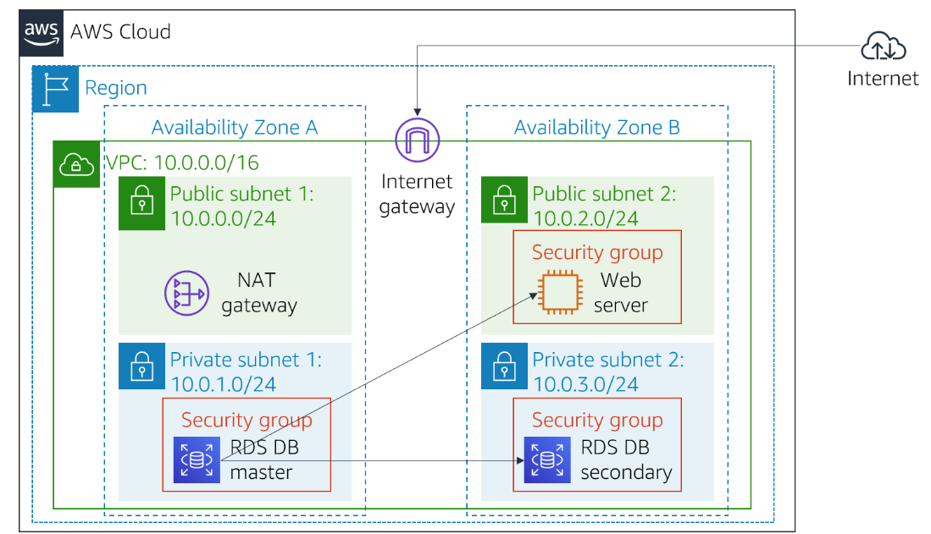

Accessing the AWS Management Console

Task 1: Create a Security Group for the RDS DB Instance
In this task, you will create a security group to allow your web server to access your RDS DB instance. The security group will be used when you launch the database instance.
- In the AWS Management Console, in the search box next to Services , search for and select VPC.
- In the left navigation pane, choose Security groups.
- Choose Create security group and then configure:
  - Security group name: DB Security Group
  - Description: Permit access from Web Security Group
  - VPC: Lab VPC
Tip: Choose the X next to VPC that is already selected, then choose Lab VPC from the menu.

- In the Inbound rules pane, choose Add rule
The security group currently has no rules. You will add a rule to permit access from the Web Security Group.

- Configure the following settings:
  - Type: MySQL/Aurora (3306)
  - Source: Place you cursor in the field to the right of Custom, type sg, and then select Web Security Group.
This configures the Database security group to permit inbound traffic on port 3306 from any EC2 instance that is associated with the Web Security Group.

- Choose Create security group
You will use this security group when launching an Amazon RDS database in this lab.

Task 2: Create a DB Subnet Group
In this task, you will create a DB subnet group that is used to tell RDS which subnets can be used for the database. Each DB subnet group requires subnets in at least two Availability Zones.
- In the AWS Management Console, in the search box next to Services , search for and select RDS.

- In the left navigation pane, choose Subnet groups.
If the navigation pane is not visible, choose the menu icon in the top-left corner.

- Choose Create DB Subnet Group then configure:
  - Name: DB-Subnet-Group
  - Description: DB Subnet Group
  - VPC: Lab VPC

- Scroll down to the Add subnets section.

- Expand the list of values under Availability Zones and select the first two zones: us-east-1a and us-east-1b.

- Expand the list of values under Subnets and select the subnets associated with the CIDR ranges 10.0.1.0/24 and 10.0.3.0/24.
These subnets should now be shown in the Subnets selected table.

- Choose Create
You will use this DB subnet group when creating the database in the next task.

Task 3: Create an Amazon RDS DB Instance
In this task, you will configure and launch a Multi-AZ Amazon RDS deployment of a MySQL database instance.
Amazon RDS Multi-AZ deployments provide enhanced availability and durability for Database (DB) instances, making them a natural fit for production database workloads. When you provision a Multi-AZ DB instance, Amazon RDS automatically creates a primary DB instance and synchronously replicates the data to a standby instance in a different Availability Zone (AZ).
- In the left navigation pane, choose Databases.

- Choose Create database
If you see Switch to the new database creation flow at the top of the screen, please choose it.

- Select MySQL under Engine Options.

- Under Templates choose Dev/Test.

- Under Availability and durability choose Multi-AZ DB instance.

- Under Settings, configure:
  - DB instance identifier: lab-db
  - Master username: main
  - Master password: lab-password
  - Confirm password: lab-password

- Under DB instance class, configure:
  - Select Burstable classes (includes t classes).
  - Select db.t3.micro

- Under Storage, configure:
  - Storage type: General Purpose (SSD)
  - Allocated storage: 20

- Under Connectivity, configure:
  - Virtual Private Cloud (VPC): Lab VPC

- Under Existing VPC security groups, from the dropdown list:
  - Choose DB Security Group.
  - Deselect default.
- Under Monitoring expand Additional configuration.
  - Uncheck Enable Enhanced monitoring.
- Under Additional configuration, configure:
  - Initial database name: lab
  - Uncheck Enable automatic backups.
  - Uncheck Enable encryption
This will turn off backups, which is not normally recommended, but will make the database deploy faster for this lab.
- Choose Create database
Your database will now be launched.
If you receive an error that mentions "not authorized to perform: iam:CreateRole", make sure you unchecked Enable Enhanced monitoring in the previous step.

- Choose lab-db (choose the link itself).
You will now need to wait approximately 4 minutes for the database to be available. The deployment process is deploying a database in two different Availability zones.
While you are waiting, you might want to review the Amazon RDS FAQs or grab a cup of coffee.

- Wait until Info changes to Modifying or Available.

- Scroll down to the Connectivity & security section and copy the Endpoint field.
It will look similar to: lab-db.xxxx.us-east-1.rds.amazonaws.com.

- Paste the Endpoint value into a text editor. You will use it later in the lab.

Task 4: Interact with Your Database
In this task, you will open a web application running on a web server that has been created for you. You will configure it to use the database that you just created.
- To discover the WebServer IP address, choose on the AWS Details drop down menu above these instructions. Copy the IP address value.

- Open a new web browser tab, paste the WebServer IP address and press Enter.
The web application will be displayed, showing information about the EC2 instance.

- Choose the RDS link at the top of the page.
You will now configure the application to connect to your database.

- Configure the following settings:
  - Endpoint: Paste the Endpoint you copied to a text editor earlier
  - Database: lab
  - Username: main
  - Password: lab-password
  - Choose Submit
A message will appear explaining that the application is running a command to copy information to the database. After a few seconds the application will display an Address Book.
The Address Book application is using the RDS database to store information.

- Test the web application by adding, editing and removing contacts.
The data is being persisted to the database and is automatically replicating to the second Availability Zone.
